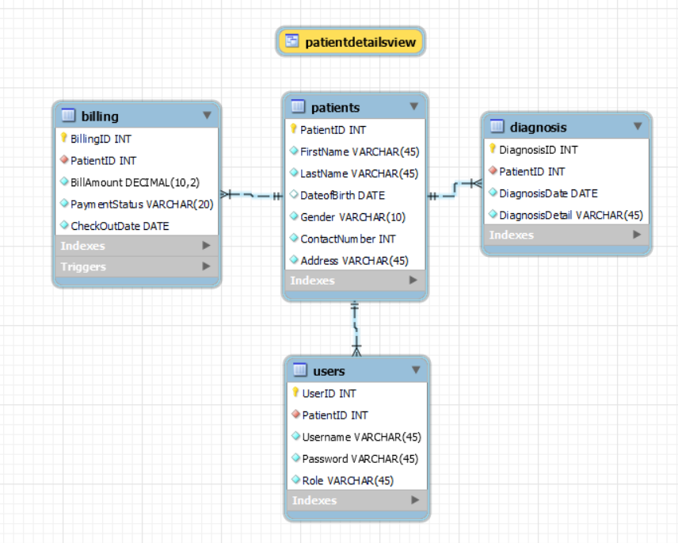 **Database Schema Diagram:**

**Outputs:**

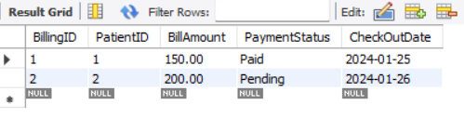

Billing Table

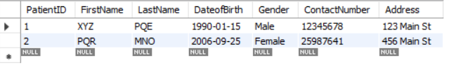

Patients Table

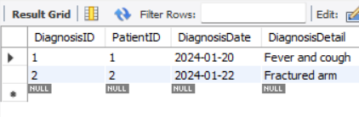

Diagnosis Table

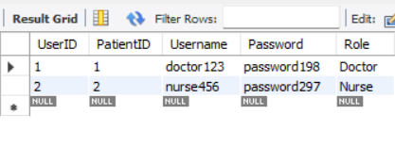

users Table

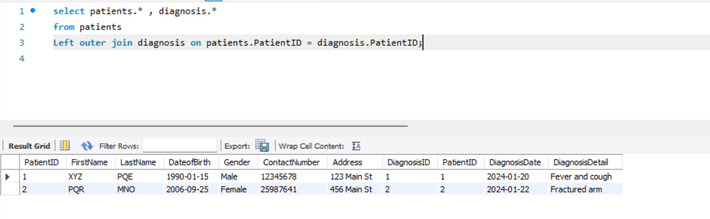**Left Outer Join ( patient table with diagnosis table)**

**View(patient_details from Patient Table )**

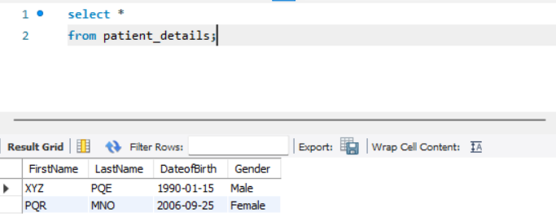

The schema is designed in 3F to ensure the elimination of transitive dependency, reduction of redundant data and data anomalies.

Eg. The attributes DiagnosisID , DiagnosisDate , PatientID and DiagnosisDetails have no transitive dependencies and all the attributes except the PatientID are directly dependent on PatientID.